

**Assignment No. 2**

**Title:** Case Study for successful real-life implementation of PWA.

**1. Introduction**

**What is a Progressive Web App (PWA)?**

A Progressive Web App (PWA) is a web application that blends the best features of websites and native apps. It offers an app-like experience directly through a browser, eliminating the need for installation from an app store. PWAs provide fast performance, offline functionality, and cross-platform accessibility by utilizing service workers and caching.



**Progressive Web App: Spotify**

Spotify launched a Web App PWA to offer an accessible, lightweight, and high-performance music experience across devices. Native apps required significant storage, frequent updates, and were sometimes restricted by app stores, delaying feature rollouts. The PWA addressed these issues, enabling seamless music streaming without the need for installation.

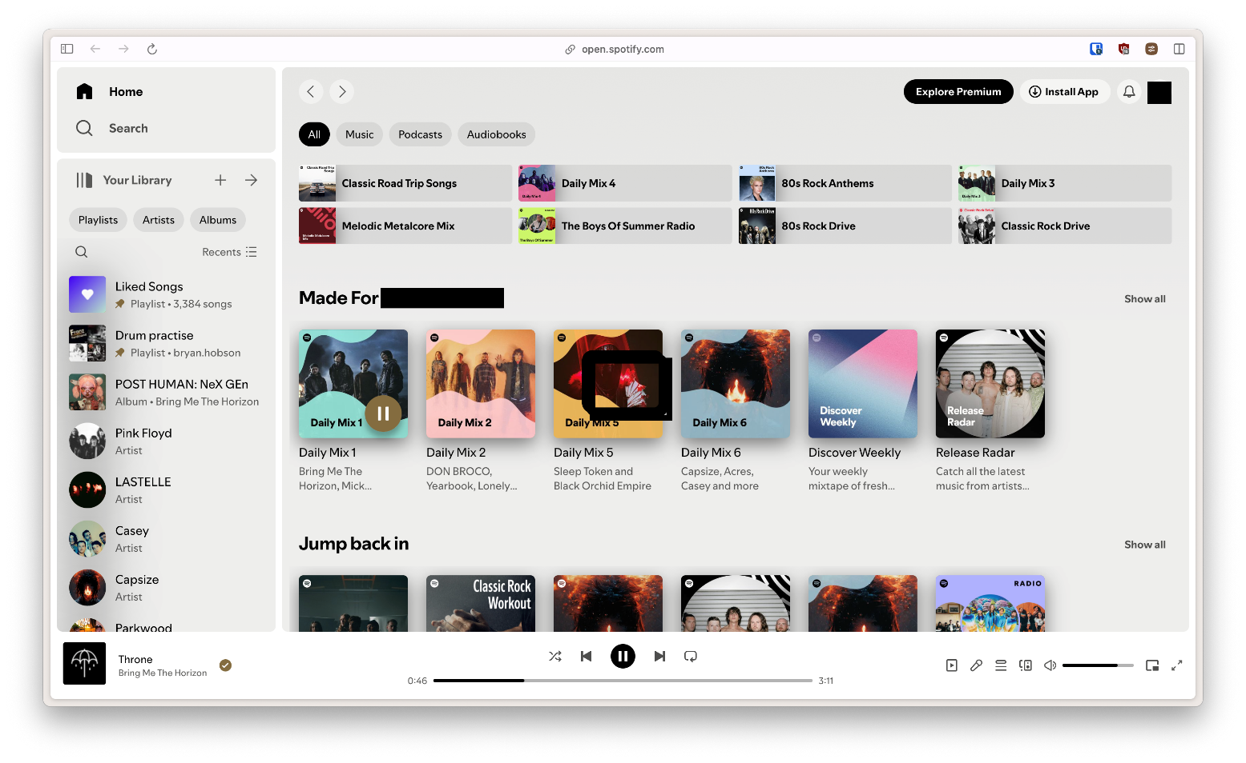

Fig no. 1 – Spotify PWA Homepage.

**2. Background & Problem Statement**

Before adopting a PWA, Spotify faced key challenges:

* Storage limitations – Native apps occupied large storage space.
* Frequent updates – Users had to update their apps regularly.
* High data consumption – Streaming large audio files consumed excessive bandwidth.
* App store restrictions – Feature rollouts were sometimes delayed due to approval processes.

To overcome these limitations, Spotify required a cross-platform solution with lower storage requirements, faster performance, and improved accessibility.

**3. Goals & Objectives**

Spotify aimed to achieve the following with its PWA:

* Provide a fast and responsive music streaming experience.
* Ensure cross-device accessibility with a single web-based application.
* Reduce load times and data consumption for users with limited bandwidth.
* Implement offline functionality for continued playback without internet connectivity.
* Enhance user engagement by allowing background playback and push notifications.

**4. Features of Spotify PWA**

Spotify’s PWA incorporates several powerful features that enhance user experience and make it a viable alternative to the native app.

**1. Instant Play & Lightweight Interface:**

Unlike the native app, the Spotify Web App PWA does not require installation. Users can access it instantly via their browser and start streaming music. The minimalistic and responsive interface ensures smooth navigation across both desktop and mobile devices.

**2. Offline Playback with Caching:**

One of the most critical features of the Spotify PWA is offline playback. Using service workers, the app caches recently played songs so that users can continue listening even without an active internet connection. This feature is particularly useful for users who travel frequently or experience network disruptions.

**3. Background Playback Support:**

The PWA allows users to play music in the background, even when switching between browser tabs or using other apps. This makes it convenient for multitasking while listening to music, a feature that was previously exclusive to native apps.

**4. Cross-Device Synchronization:**

Users can seamlessly switch between devices while retaining their playlist and playback position. Whether using the Spotify Web App on a laptop, tablet, or mobile phone, the user experience remains consistent and synchronized.

**5. Add to Home Screen & App-Like Experience:**

The Web App Manifest enables users to install the Spotify PWA on their home screen, making it function almost like a native app. Once installed, it runs in a standalone window, providing a distraction-free music streaming experience without browser elements.

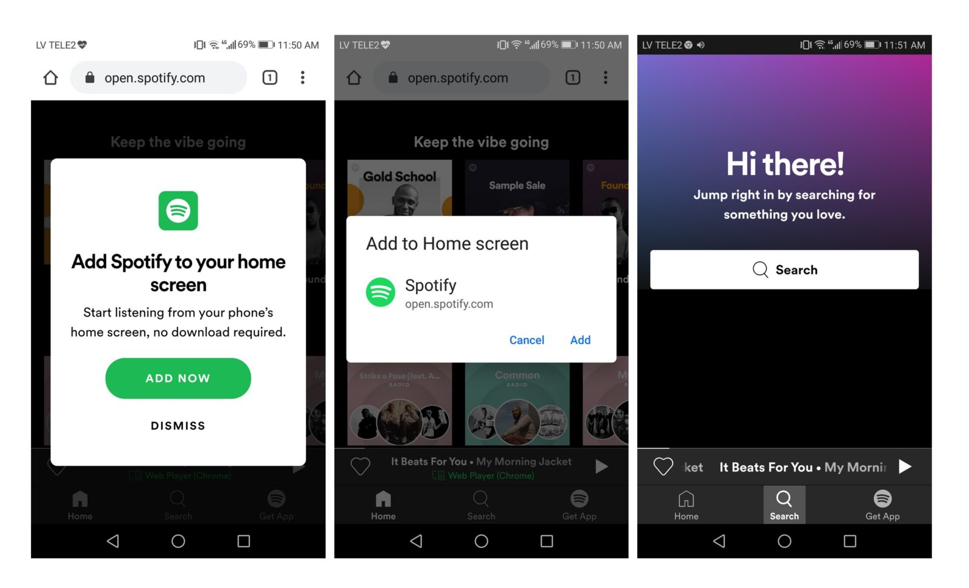

Fig no. 2 – Add to Home Screen Feature

**5. PWA Implementation**

Spotify’s PWA is built using modern web technologies to ensure speed, security, and reliability.

Technologies Used:

* Service Workers – Enable offline caching and background sync.
* Web App Manifest – Allows users to install the web app on their home screen.
* Responsive Web Design – Ensures smooth functionality across all screen sizes.
* HTTPS Encryption – Secures data and ensures safe streaming.

Key Features Implemented:

* Instant playback with fast load times.
* Offline caching for previously played songs.
* Push notifications (in development) for new releases and updates.
* Cross-device syncing for seamless listening.

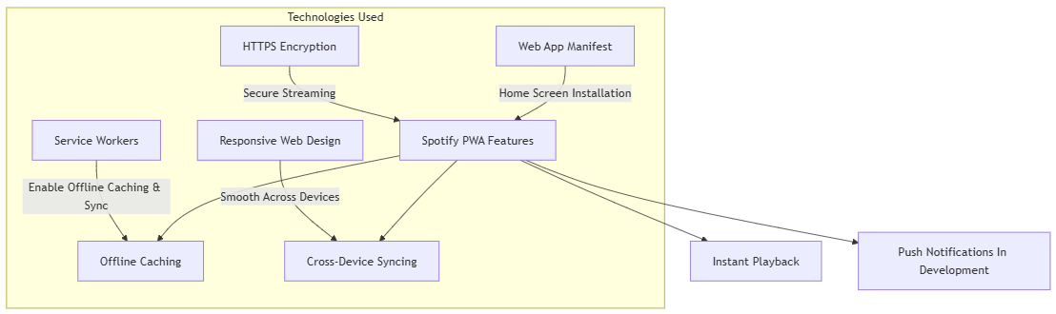

Fig no. 3 – Spotify PWA Features Implementation.

**6. Results & Impact**

Spotify’s PWA delivered significant improvements in performance and accessibility:

* 30% faster load times compared to the previous web player.
* Lower data consumption due to optimized caching and streaming.
* Higher engagement rates, as users could access the service without downloads.
* Increased accessibility for users with low-end devices or limited storage.

**7. User Experience & Feedback**

Positive Feedback:

Many users appreciated the quick access, smooth interface, and lower storage usage of the PWA. It became particularly popular among users who wanted a lightweight alternative to the native app while still enjoying core functionalities.

Areas for Improvement:

* Some users requested full offline downloads rather than just cached songs.
* Equalizer settings and advanced audio features were not as robust as in the native app.
* Background playback functionality was sometimes restricted by certain browsers.

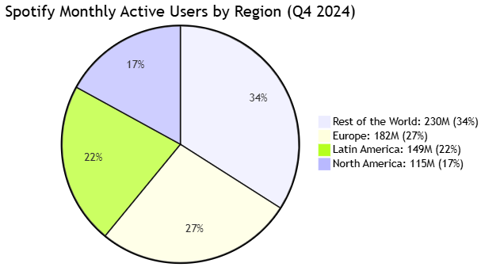

Fig no. 4 – Spotify User Engagement.

**8. Challenges & Learnings**

Developing the Spotify Web App PWA came with its share of challenges:

* Offline playback required balancing caching efficiency and licensing restrictions.
* Background playback support was inconsistent across different browsers.
* Ensuring smooth performance on mobile while maintaining audio quality was complex.

Spotify’s team learned that progressive enhancement—where the app delivers core functionalities universally while adding advanced features where supported—was the best approach.

**9. Conclusion & Future Scope**

The Spotify Web App PWA successfully improved accessibility, speed, and performance while providing an app-like experience. By leveraging modern web technologies, Spotify was able to reach a wider audience and provide a seamless music streaming experience without requiring an app store installation.

Future Improvements:

* Expanding offline playback to allow full playlist downloads.
* Enhancing push notification support for new song releases.
* Improving media controls integration across browsers.

Spotify’s PWA stands as a strong example of how businesses can use Progressive Web Apps to enhance user engagement while reducing reliance on traditional app ecosystems.